Geometry: Unit 6, Lesson 6
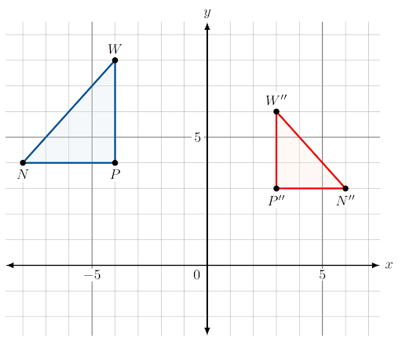
- Triangle $W''N''P''$ is the result of a transformation of $∆WNP$ as shown. The side lengths of $∆WNP$ are $4$, $4$, and $4\sqrt{2}$. The side lengths of the corresponding sides of $∆W''N''P''$ are $3$, $3$, and $3\sqrt{2}$, respectively. What is the relationship between $∆W''N''P''$ and $∆WNP$?

$∆W''N''P''$ is a dilation of $∆WNP$

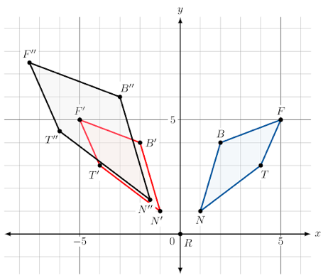
- Quadrilaterals $NBFT$, $N'B'F'T'$, and $N''B''F''T''$ are shown on the coordinate grid. What transformation was applied to create $N'B'F'T'$ from $NBFT$?

Reflection over the $y$-axis

- A rotation is an example of a rigid transformation because what is preserved?

Both angle measures and distances

